**ST.XAVIER’S COLLEGE**

MAITIGHAR, KATHMANDU



Computer Graphics

Assignment #3

Submitted By:

Abhishek Tamrakar

013BSCCSIT003

2nd year/ 4th semester

Submitted to:

|  |  |
| --- | --- |
| Er. Anil K. Sah  Lecturer  Department of Computer Science |  |

**STATEMENT**

Write a program to draw a line using DDA algorithm in C++ builder.

#include <vcl\vcl.h>

#pragma hdrstop

#include "dda.h"

//---------------------------------------------------------------------------

#pragma resource "*.dfm"

int x1,x2,y1,y2,m;

TForm1 *Form1;

//---------------------------------------------------------------------------

void __fastcall TForm1::Edit1Change(TObject *Sender)

{

x1=StrToInt(Edit1->Text);

}

//---------------------------------------------------------------------------

void __fastcall TForm1::Edit2Change(TObject *Sender)

{

y1=StrToInt(Edit2->Text);

}

//---------------------------------------------------------------------------

void __fastcall TForm1::Edit3Change(TObject *Sender)

{

x2=StrToInt(Edit3->Text);

}

//---------------------------------------------------------------------------

void __fastcall TForm1::Edit4Change(TObject *Sender)

{

y2=StrToInt(Edit4->Text);

}

//---------------------------------------------------------------------------

void __fastcall TForm1::DRAWClick(TObject *Sender)

{

int i,x,y;

m=(y2-y1)/(x2-x1);

for(i=x1;i<x2;i++)

{

if(m<1)

{

x=1;

y=m*x;

}

else

{

y=1;

x=y/m;

}

x1=x1+x;

y1=y1+y;

Image1->Canvas->Pixels[x1][y1] = RGB(0,0,255);

}

}

//---------------------------------------------------------------------------

**OUTPUT SCREENS**

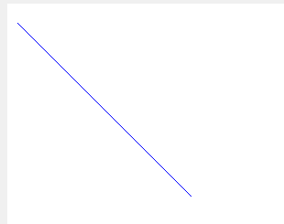 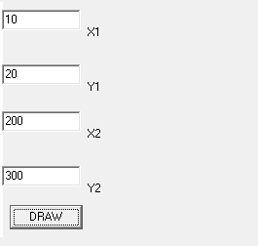

**CONCLUSION**

Hence, a program to draw a line was implemented using DDA algorithm in C++ builder.